Moore Digital Archive

# Editing Description Document

Version 1.0

01/16/2020

Document Number: 1A

Contract Name and Number: Tejas Magar (716-4792695)

Please follow the steps below for editing the documents: -

1. Go to the CWRC site: - <https://cwrc-writer.cwrc.ca/>
2. After that a screen will appear showing the various repositories (like below screenshot):-

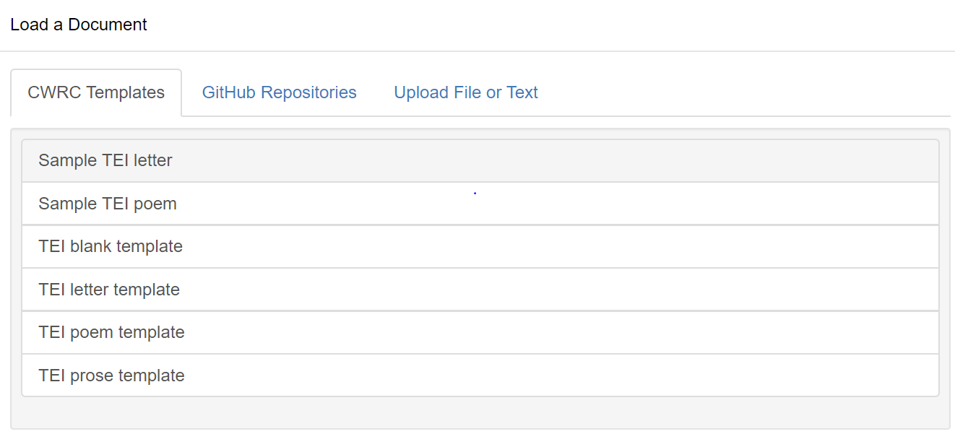

Fig 1. Loading a document in editor

1. Next , click on GitHub Repositories > [**tejasmagar/CWRC-GitServer**](https://cwrc-writer.cwrc.ca/) >mmda_tei_samplenew.xml

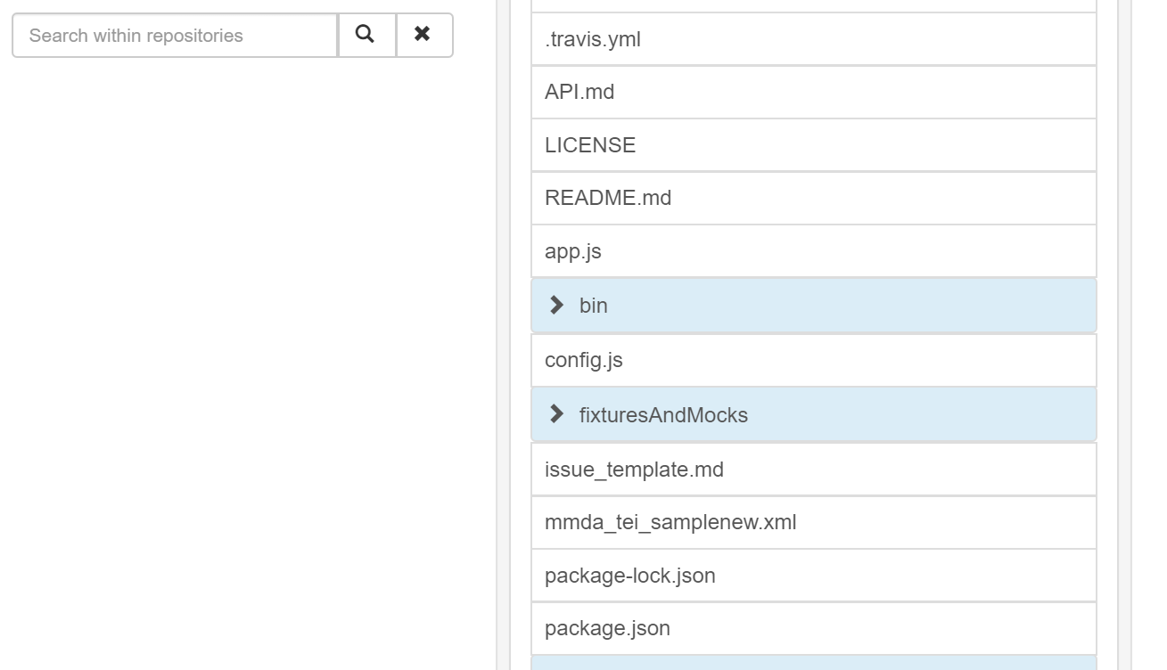

Fig 2. Path to xml file

1. The editor will open with the tags and the images , after which the editing actions could be performed.

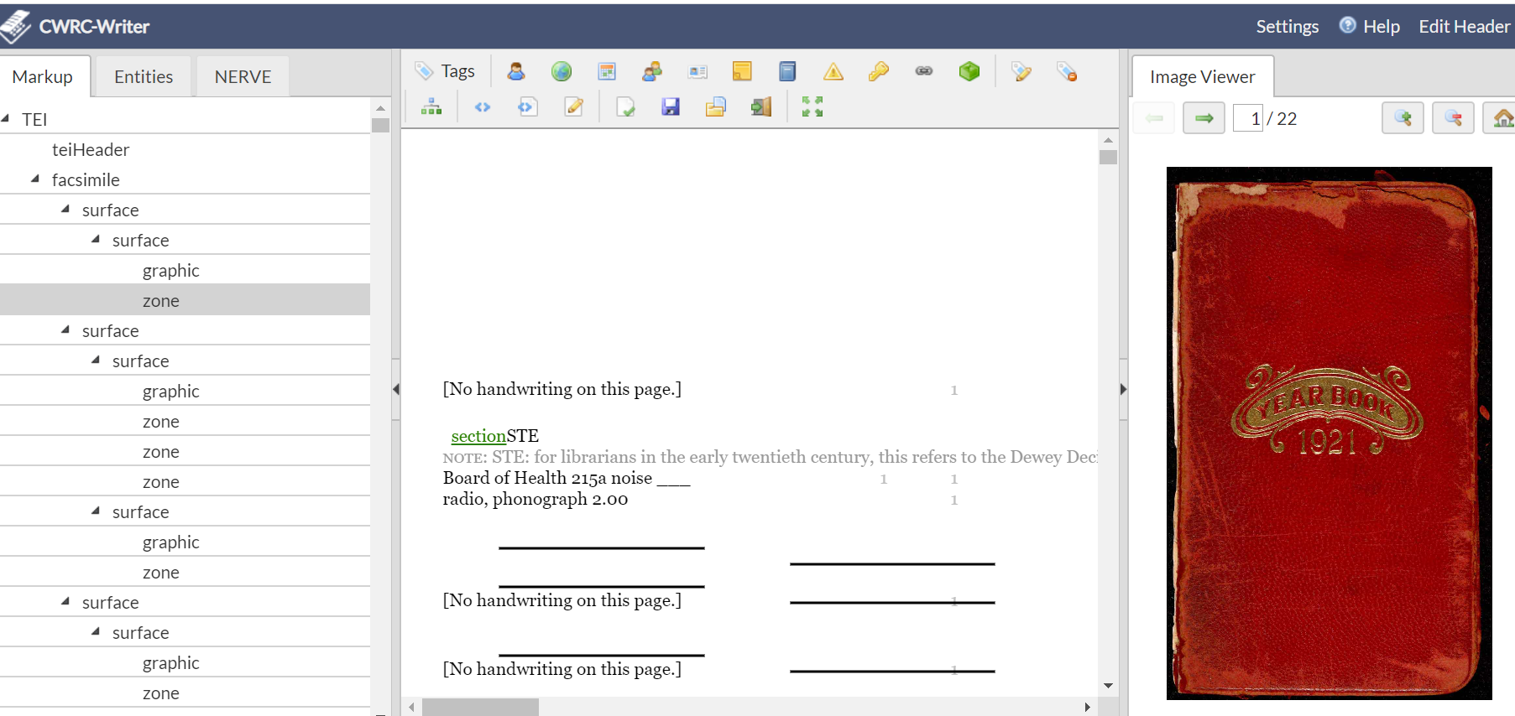

Fig 3. Editor in CWRC